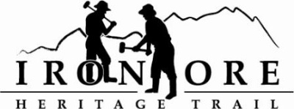
102 W. Washington Suite 232
Marquette, MI 49855
906-235-2923
ironoreheritage@gmail.com
IRON ORE HERITAGE RECREATION AUTHORITY
BOARD MEETING
THURSDAY, OCTOBER 29, 4:30 PM, COUNTRY INN AND SUITES

DRAFT AGENDA

- ROLL CALL
- PUBLIC COMMENT ( Agenda Items – Limit to three minutes)
- APPROVAL OF CONSENT AGENDA
  - September Financials including balance sheet, profit/loss, budget v actual and general ledger
  - October Bills to Be Paid
- APPROVAL OF AGENDA
- OLD BUSINESS
  - Phase IV –
1. Republic project
2. Ishpeming/Tilden Project
B. ORV Ordinance Ishpeming
C. Grant Updates
1. ArtPlace America 2016
2. 2015 Recreation Passport
D. Dark Store/Tax Loophole Forum – November 5

- NEW BUSINESS
  - 2016 Draft Budget/Plans
  - MATAG Conference/Trail Award
  - December 4 Ribbon Cutting and Municipal Member Celebration
  - Millage Renewal Timeline/Information
  - Municipal Ride Through – Spring 2016

- BOARD COMMENT
- PUBLIC COMMENT
- ADJOURNMENT

NEXT MEETING DATE: NOVEMBER 18, 2015, COUNTRY INN AND SUITES

