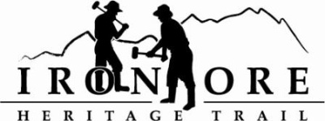

**102 W. Washington Suite 232  
Marquette, MI 49855  
906-235-2923**[**ironoreheritage@gmail.com**](mailto:ironoreheritage@gmail.com)

**IRON ORE HERITAGE RECREATION AUTHORITY  
 BOARD MEETING**

**WEDNESDAY, AUGUST 23, 2023, 4:30 PM**

**ISHPEMING SENIOR CENTER**

**DRAFT AGENDA**

1. ROLL CALL
2. PUBLIC COMMENT (Agenda Items – Limit to three minutes)
3. APPROVAL OF CONSENT AGENDA
   1. July Minutes
   2. July Financials
   3. August Bills to be Paid
4. APPROVAL OF AGENDA
5. EVENT PERMITS – Marji Gesick Sept. 15-17
6. OLD BUSINESS
7. Projects
   * 1. Negaunee Boardwalk
     2. Lakenenland
     3. Property Acquisition,176 acres
     4. Winthrop Junction Update
     5. ORV Bridge Repair
     6. Howard Oil Trailhead and Lighting
     7. Republic Township Millage Vote
     8. Maintenance List
8. NEW BUSINESS
   1. ORV Trail Extension Project
   2. Fishing Pier Deck, Section 61, Ishpeming
9. ADMINISTRATOR REPORT
10. BOARD COMMENT
11. PUBLIC COMMENT
12. ADJOURNMENT *NEXT MEETING DATE: Wednesday, July 26, 2023, 4:30 pm Ishpeming Senior Center and Zoom*