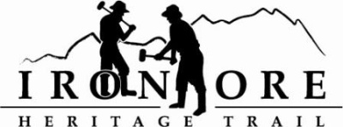
102 W. Washington Suite 232
Marquette, MI 49855
906-235-2923
ironoreheritage@gmail.com

IRON ORE HERITAGE RECREATION AUTHORITY
ANNUAL BOARD MEETING
WEDNESDAY, APRIL 26, 4:30 PM
ISHPEMING SENIOR CENTER
DRAFT AGENDA
- ROLL CALL

- PUBLIC COMMENT (Agenda Items – Limit to three minutes)

- APPROVAL OF CONSENT AGENDA
  - March Minutes
  - March Financials
  - April Bills to be Paid
- APPROVAL OF AGENDA
- OLD BUSINESS
- Michigan Grant Updates
    - Michigan Recreation Passport Trail/Trailhead Amenities
    - Michigan Trust Fund Grant Trail/Trailhead Amenities
- Projects
    - Negaunee Boardwalk
    - Lakenenland
    - Property Acquisition,176 acres
    - Winthrop Junction Update
    - Hiring Committee Report
    - Maintenance Vehicles purchase: truck, tractor, trailer
    - Maintenance List 2023
VI. NEW BUSINESS
    - Republic Township Membership Continuation and Ballot Language Resolution
    - ORV Grant Application and 2023 Grant Amendment

- ADMINISTRATOR REPORT
- BOARD COMMENT
- PUBLIC COMMENT
- ADJOURNMENT
NEXT MEETING DATE: Wednesday, MAY 24, 2023, 4:30 pm Ishpeming Senior Center and Zoom

