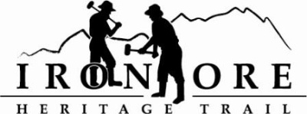
102 W. Washington Suite 232
Marquette, MI 49855
906-235-2923
ironoreheritage@gmail.com

IRON ORE HERITAGE RECREATION AUTHORITY
BOARD MEETING
WEDNESDAY, MARCH 22, 4:30 PM
ISHPEMING SENIOR CENTER
DRAFT AGENDA
- ROLL CALL

- PUBLIC COMMENT (Agenda Items – Limit to three minutes)

- PUBLIC HEARING – Michigan Recreation Passport Grant Application RP23.0053, Ishpeming Trail and Trailhead Amenities
PUBLIC HEARING – Michigan Trust Fund Grant Application TF23.0121, Ishpeming Trail and Trailhead Amenities

- APPROVAL OF CONSENT AGENDA
  - February Minutes
  - February Financials
  - March Bills to be Paid
- APPROVAL OF AGENDA
- OLD BUSINESS
- Michigan Grant Updates
    - MDARD Grant 2022
    - Michigan Recreation Passport Trail/Trailhead Amenities
        - Background
        - Resolution
    - Michigan Trust Fund Grant Trail/Trailhead Amenities
a. Background
b. Resolution
- Projects
    - Negaunee Boardwalk
    - Lakenenland
    - Property Acquisition,176 acres
    - Trail Sustainability Update
    - Winthrop Junction Update
    - Hiring Committee Report
    - Maintenance Vehicle

- ADMINISTRATOR REPORT
- BOARD COMMENT
- PUBLIC COMMENT
- ADJOURNMENT
NEXT MEETING DATE: Annual Meeting, Wednesday, April 26, 2022, 4:30 pm Ishpeming Senior Center and Zoom, Congress Pizza Appreciation Night afterwards

