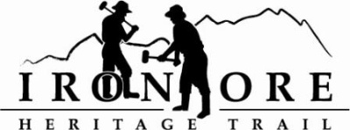
102 W. Washington Suite 232
Marquette, MI 49855
906-235-2923
ironoreheritage@gmail.com

IRON ORE HERITAGE RECREATION AUTHORITY
BOARD MEETING
WEDNESDAY, JANUARY 25, 2022, 4:30 PM
ISHPEMING SENIOR CENTER
DRAFT AGENDA
- ROLL CALL

- PUBLIC COMMENT (Agenda Items – Limit to three minutes)

- APPROVAL OF CONSENT AGENDA
  - December Minutes
  - December Financials
  - January Bills to be Paid
- APPROVAL OF AGENDA
- OLD BUSINESS
- Michigan Grant Updates
    - 2021 Trust Fund Negaunee Boardwalk
    - 2022 MNRTF Development Grant for Lakenenland
    - 2022 MNRTF Acquisition
    - Michigan Spark Grant , Lakenenland
    - Michigan Spark Grant 2, Trust Fund and/or Rec Passport, Lighting
    - MDARD Grant 2022
- Negaunee Campground Environmental Assessment Lease Addendum

- NEW BUSINESS
  - Administrator Hiring Committee Schedule
  - 2023 Priorities
  - Proposed ORV Route Negaunee Ice Arena to 492/35 with r/r crossing

- ADMINISTRATOR REPORT
- BOARD COMMENT
- PUBLIC COMMENT
- ADJOURNMENT
NEXT MEETING DATE: Wednesday, February 22, 2022, 4:30 pm Ishpeming Senior Center and Zoom,

