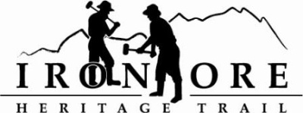
102 W. Washington Suite 232
Marquette, MI 49855
906-235-2923
ironoreheritage@gmail.com

IRON ORE HERITAGE RECREATION AUTHORITY
BOARD MEETING
WEDNESDAY, FEBRUARY 25, 2022, 4:30 PM
ISHPEMING SENIOR CENTER
DRAFT AGENDA
- ROLL CALL

- PUBLIC COMMENT (Agenda Items – Limit to three minutes)

- APPROVAL OF CONSENT AGENDA
  - January Minutes
  - January Financials
  - February Bills to be Paid
- APPROVAL OF AGENDA
- 2023 IRON RANGE ROLL EVENT PERMIT
- OLD BUSINESS
- Michigan Grant Updates
    - Michigan Spark Grant 1 & 2, Lakenenland
    - MDARD Grant 2022
- Projects
    - Negaunee Boardwalk
    - Lakenenland - Other Grant Opportunities
    - Property Acquisition of 176 acres
    - Negaunee Township new aggregate
    - Trail Sustainability Open House
    - Winthrop Junction Update
    - Hiring Committee Report
    - Lighting - Ishpeming
- NEW BUSINESS
  - IOHRA Board Members – Ishpeming & Negaunee reps up for 2023 appointment
  - Maintenance w.o MDARD grant
  - Executive Board Action Polar Roll Ultra
  - Interpretive Sign Book

- ADMINISTRATOR REPORT
- BOARD COMMENT
- PUBLIC COMMENT
- ADJOURNMENT
NEXT MEETING DATE: Wednesday, March 22, 2022, 4:30 pm Ishpeming Senior Center and Zoom,

