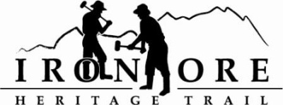
102 W. Washington Suite 232
Marquette, MI 49855
906-235-2923
ironoreheritage@gmail.com

IRON ORE HERITAGE RECREATION AUTHORITY
BOARD MEETING
WEDNESDAY, DECEMBER 21, 2022, 4:30 PM
ISHPEMING SENIOR CENTER
DRAFT AGENDA
- ROLL CALL

- PUBLIC COMMENT (Agenda Items – Limit to three minutes)

- PUBLIC HEARING – 2023-2028 RECREATION PLAN

- APPROVAL OF CONSENT AGENDA
  - November Minutes
  - November Financials
  - December Bills to be Paid
- APPROVAL OF AGENDA
- OLD BUSINESS
- Michigan Grant Updates
    - 2021 Trust Fund Negaunee Boardwalk
    - 2022 MNRTF Development Grant for Lakenenland
    - 2022 MNRTF Acquisition
    - Michigan Spark Grant
    - Michigan Spark Grant II, Lighting
- 2023 Recreation Plan Approval/Resolution to Submit, Roll call vote
- Negaunee Campground Environmental Assessment Update

- NEW BUSINESS
  - 2022 Budget Amendment, Roll Call Vote
  - 2023 Meeting Schedule
  - Letters of support policy

- ADMINISTRATOR REPORT
- BOARD COMMENT
- PUBLIC COMMENT
- ADJOURNMENT
NEXT MEETING DATE: Wednesday, January 25, 2022, 4:30 pm Ishpeming Senior Center and Zoom,

