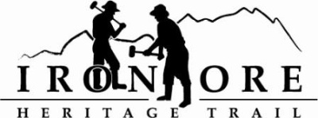
102 W. Washington Suite 232
Marquette, MI 49855
906-235-2923
ironoreheritage@gmail.com

IRON ORE HERITAGE RECREATION AUTHORITY
BOARD MEETING
WEDNESDAY, NOVEMBER 30, 2022, 4:30 PM
HOLIDAY INN EXPRESS
DRAFT AGENDA
- ROLL CALL

- PUBLIC COMMENT (Agenda Items – Limit to three minutes)

- APPROVAL OF CONSENT AGENDA
  - October Minutes
  - October Financials
  - November Bills to be Paid
- APPROVAL OF AGENDA
- EVENTS – Polar Roll Application
- OLD BUSINESS
- Michigan Grant Updates
    - 2021 Trust Fund Negaunee Boardwalk
    - 2022 MNRTF Development Grant for Lakenenland – Score 380
    - 2022 MNRTF Acquisition - Score 355
    - Michigan Spark Grants Resolution to Submit, Due December 19
    - MDARD Grant Submittal
- 2023 Recreation Plan Update
- Negaunee Campground Environmental Phase I
- Marquette Trail Sustainability Meeting Update
- NEW BUSINESS
  - 2023 Draft 2 Budget
  - 2023 Hiring
  - Annual Municipal Report

- ADMINISTRATOR REPORT
- BOARD COMMENT
- PUBLIC COMMENT
- ADJOURNMENT
NEXT MEETING DATE: Wednesday, December 21, 2022, 4:30 pm Ishpeming Senior Center and Zoom,

