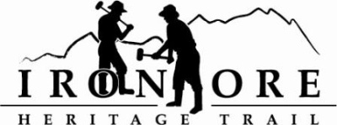
102 W. Washington Suite 232
Marquette, MI 49855
906-235-2923
ironoreheritage@gmail.com

IRON ORE HERITAGE RECREATION AUTHORITY
BOARD MEETING
WEDNESDAY, OCTOBER 26, 2022, 4:30 PM
ISHPEMING SENIOR CENTER
DRAFT AGENDA
- ROLL CALL

- PUBLIC COMMENT (Agenda Items – Limit to three minutes)

- PUBLIC HEARING – 2023 RECREATION PLAN INPUT
- APPROVAL OF CONSENT AGENDA
  - September Minutes
  - September Financials
  - October Bills to be Paid
- APPROVAL OF AGENDA
- OLD BUSINESS
- Michigan Grant Updates
    - 2021 Trust Fund Negaunee Boardwalk
    - 2022 MNRTF Development Grant for Lakenenland – Score 380
    - 2022 MNRTF Acquisition - Score 355
    - Michigan Spark Grants Update
    - MDARD Grant
- 2023 Recreation Plan Update
- Negaunee Campground Environmental
- Maintenance List
- Marquette Trail Sustainability Meeting October, 6 to 8 pm
- NEW BUSINESS
  - 2022 Budget YTD
  - 2023 Priorities & Draft 1 Budget
  - 2023 Hiring
  - December meeting date

- ADMINISTRATOR REPORT
- BOARD COMMENT
- PUBLIC COMMENT
- ADJOURNMENT
NEXT MEETING DATE: Wednesday, November 30, 2022, 4:30 pm Ishpeming Senior Center and Zoom,

