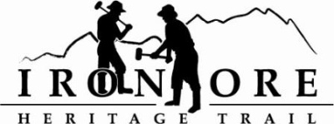
102 W. Washington Suite 232
Marquette, MI 49855
906-235-2923
ironoreheritage@gmail.com

IRON ORE HERITAGE RECREATION AUTHORITY
BOARD MEETING
WEDNESDAY, SEPTEMBER 28, 2022, 4:30 PM
ISHPEMING SENIOR CENTER
DRAFT AGENDA
- ROLL CALL

- PUBLIC COMMENT (Agenda Items – Limit to three minutes)
- APPROVAL OF CONSENT AGENDA
  - August Minutes
  - August Financials
  - September Bills to be Paid
- APPROVAL OF AGENDA
- OLD BUSINESS
- Michigan Grant Updates
    - 2021 Trust Fund Negaunee Boardwalk
    - 2022 MNRTF Development Grant for Lakenenland – Score 380
    - 2022 MNRTF Acquisition - Score 355
    - Michigan Spark Grants Update
- 2023 Recreation Plan Update
- 2022 Maintenance List
- ORV Grant 2023, Parking Areas and Possible Extension of Trail to 492/35
- Executive Committee Meeting September 21 Review

- NEW BUSINESS
  - 2023 Priorities
  - October Public Hearing for Recreation Plan Input
  - Events – Clean up, recognition, logo use

- ADMINISTRATOR REPORT
- BOARD COMMENT
- PUBLIC COMMENT
- ADJOURNMENT
NEXT MEETING DATE: Wednesday, October 26, 2022, 4:30 pm Ishpeming Senior Center and Zoom,

