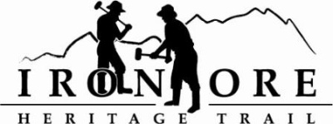
102 W. Washington Suite 232
Marquette, MI 49855
906-235-2923
ironoreheritage@gmail.com

IRON ORE HERITAGE RECREATION AUTHORITY
BOARD MEETING
WEDNESDAY, AUGUST 24, 2022, 4:30 PM
ISHPEMING SENIOR CENTER
DRAFT AGENDA
- ROLL CALL

- PUBLIC COMMENT (Agenda Items – Limit to three minutes)
- APPROVAL OF CONSENT AGENDA
  - July Minutes
  - July Financials
  - August Bills to be Paid
- APPROVAL OF AGENDA
- OLD BUSINESS
- Michigan Grant Updates
    - 2021 Trust Fund Negaunee Boardwalk
    - 2022 MNRTF Development Grant for Lakenenland and Lease Language
    - 2022 MNRTF Acquisition
    - Michigan Spark Grants Update
- Millage Renewal Update
- 2023 Recreation Plan Update
- 2022 Maintenance List
- ORV Parking Areas, Stoneville and Washington Street
- Proposed Executive Committee Meeting
- Humboldt Township Meeting
- NEW BUSINESS
  - Marji Gesick Event Permit
  - Interpretive Sign Costs

- ADMINISTRATOR REPORT
- BOARD COMMENT
- PUBLIC COMMENT
- ADJOURNMENT
NEXT MEETING DATE: Wednesday, September 28, 2022, 4:30 pm Ishpeming Senior Center and Zoom,

