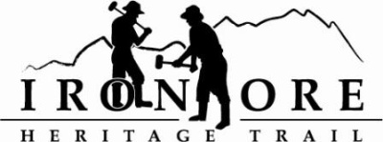
102 W. Washington Suite 232
Marquette, MI 49855
906-235-2923
ironoreheritage@gmail.com

IRON ORE HERITAGE RECREATION AUTHORITY
BOARD MEETING
WEDNESDAY, FEBRUARY 23, 2022, 4:30 PM
U.P. STATE BANK
DRAFT AGENDA
- ROLL CALL
- PUBLIC COMMENT (Agenda Items – Limit to three minutes)
- APPROVAL OF CONSENT AGENDA
  - January Minutes
  - January Financials
  - February Bills to be Paid
- APPROVAL OF AGENDA
- OLD BUSINESS
- Michigan Grant Updates
    - 2021 Trust Fund Negaunee Boardwalk
    - 2022 MNRTF Development Grant for Lakenenland
      - Lease Addendum with State of Michigan Resolution to Sign
      - Trail Route/Surfacing
      - Lakenenland Accessibility issues/Iron Belle Response
    - 2022 MNRTF Acquisition Grant,
      - Appraisal
      - Grantor Conversation about Land Conservation/Green space planning
      - Regional Significant points
- Millage Renewal Update
- Negaunee Township Trailhead Project
- 2022 Maintenance Projects
  - Asphalt Repair
  - Perkins Property trailhead
- NEW BUSINESS
  - 2021 Audit Letter
  - Negaunee Request for Playground at Trailhead, Patronicity Project
- ADMINISTRATOR REPORT
- BOARD COMMENT
- PUBLIC COMMENT
- ADJOURNMENT
NEXT MEETING DATE: March 23, 2022 ,Ishpeming Senior Center and Zoom

