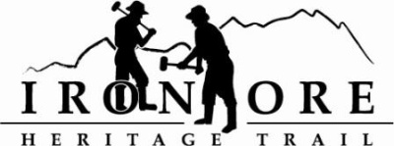
102 W. Washington Suite 232
Marquette, MI 49855
906-235-2923
ironoreheritage@gmail.com

IRON ORE HERITAGE RECREATION AUTHORITY
BOARD MEETING
WEDNESDAY, JANUARY 19, 2021, 4:30 PM
ISHPEMING SENIOR CENTER

DRAFT AGENDA
- ROLL CALL
- PUBLIC COMMENT (Agenda Items – Limit to three minutes)
- APPROVAL OF CONSENT AGENDA
  - December Minutes
  - December Financials
  - January Bills to be Paid
- APPROVAL OF AGENDA
- OLD BUSINESS
- Michigan Grant Updates
    - 2021 Trust Fund Negaunee Boardwalk
    - 2022 MNRTF Development Grant for Lakenenland
    - 2022 MNRTF Acquisition Grant,
      - Appraisal cost of $3500
      - U.P. Land Conservancy Conversation
    - MDARD Grant for Lakenenland

- Millage Renewal Resolution for millage language of .1970 mills
- Negaunee/IOHRA Land Lease Agreement Resolution
- Negaunee Township Trailhead Project

- NEW BUSINESS
  - 2022 Maintenance Projects
1. Asphalt Repair
2. ORV Grading/Bike Path mix in Tilden
3. Perkins Property Trailhead, Ishpeming (not budgeted)
B. Marquette Lions Club Letter of Support

- ADMINISTRATOR REPORT
- BOARD COMMENT
- PUBLIC COMMENT
- ADJOURNMENT
NEXT MEETING DATE: February 23, 2022, U.P. State Bank, Washington Street, Marquette and Zoom

