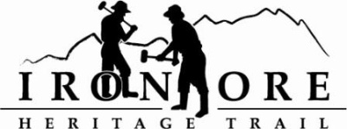
102 W. Washington Suite 232
Marquette, MI 49855
906-235-2923
ironoreheritage@gmail.com

IRON ORE HERITAGE RECREATION AUTHORITY
BOARD MEETING
WEDNESDAY, DECEMBER 15, 2021, 4:30 PM

DRAFT AGENDA
- ROLL CALL
- PUBLIC COMMENT (Agenda Items – Limit to three minutes)
- APPROVAL OF CONSENT AGENDA
  - November Minutes
  - November Financials
  - December Bills to be Paid
- APPROVAL OF AGENDA
- OLD BUSINESS
- Michigan Grant Updates
    - Negaunee Township Trailhead Award of Bid
    - 2021 Trust Fund Purchase of 176 Acres – Not awarded
    - 2021 Trust Fund Negaunee Boardwalk – Awarded
    - 2022 Michigan DNR Grant Request Discussion
- 2021 Maintenance List
- Millage Renewal Updates and Municipal Presentations
- Negaunee/IOHRA Lease Agreement

- NEW BUSINESS
  - 2022 Board Meeting Schedule
  - 2021 Municipal Updates Newsletter
  - 2022 Municipal Appointments
  - 2022 Iron Range Roll Permit

- ADMINISTRATOR REPORT
- BOARD COMMENT
- PUBLIC COMMENT
- ADJOURNMENT
NEXT MEETING DATE: January 26, 2022, 4:30 pm, Ishpeming Senior Center & Zoom

