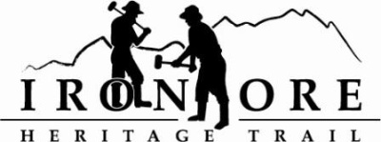
102 W. Washington Suite 232
Marquette, MI 49855
906-235-2923
ironoreheritage@gmail.com

IRON ORE HERITAGE RECREATION AUTHORITY
BOARD MEETING
WEDNESDAY,NOVEMBER 17, 2021, 4:30 PM

AGENDA
- ROLL CALL
- PUBLIC COMMENT (Agenda Items – Limit to three minutes)
- APPROVAL OF CONSENT AGENDA
  - October Minutes
  - October Financials
  - November Bills to be Paid
- APPROVAL OF AGENDA
- OLD BUSINESS
- Michigan Grant Updates
    - Negaunee Township Trailhead Award of Bid
    - 2021 Trust Fund Purchase of 176 Acres – Final score 330
    - 2021 Trust Fund Negaunee Boardwalk – Final score 295
- 2021 Maintenance List
- Millage Renewal Updates and Municipal Presentations
- Negaunee/IOHRA Interlocal Agreement

- NEW BUSINESS
  - 2021 Budget Amendment November 17, 2021
  - 2022 Draft Budget
  - State investment in parks and recreation

- ADMINISTRATOR REPORT
- BOARD COMMENT
- PUBLIC COMMENT
- ADJOURNMENT
NEXT MEETING DATE: December 15, 2021, 4:30 pm, Zoom/Country Inn

