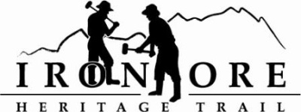
102 W. Washington Suite 232
Marquette, MI 49855
906-235-2923
ironoreheritage@gmail.com

IRON ORE HERITAGE RECREATION AUTHORITY
BOARD MEETING
WEDNESDAY,OCTOBER 27, 2021, 4:30 PM

AGENDA
- ROLL CALL
- PUBLIC COMMENT (Agenda Items – Limit to three minutes)
- APPROVAL OF CONSENT AGENDA
  - September Minutes
  - September Financials
  - October Bills to be Paid
- APPROVAL OF AGENDA
- CITY OF NEGAUNEE PRESENTATION ON CAMPGROUND/TRAILHEAD
- OLD BUSINESS
- Michigan Grant Updates
    - Negaunee Township Trailhead
    - 2021 Trust Fund Purchase of 176 Acres
    - 2021 Trust Fund Negaunee Boardwalk
- 2021 Maintenance List
  - Asphalt Repair
  - Gate Destruction
- Millage Renewal Updates and Municipal Presentations
- Pure Michigan video

- NEW BUSINESS
  - 2021 Year to Date Budget v Actual
  - 2022 Draft Budget

- ADMINISTRATOR REPORT
- BOARD COMMENT
- PUBLIC COMMENT
- ADJOURNMENT
NEXT MEETING DATE: November 17, 2021, 4:30 pm, Zoom/Country Inn

