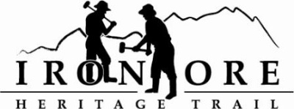
102 W. Washington Suite 232
Marquette, MI 49855
906-235-2923
ironoreheritage@gmail.com

IRON ORE HERITAGE RECREATION AUTHORITY
BOARD MEETING
WEDNESDAY, SEPTEMBER 22, 2021, 4:30 PM
Michigan Iron Industry Museum/Zoo

AGENDA
- ROLL CALL
- PUBLIC COMMENT (Agenda Items – Limit to three minutes)
- APPROVAL OF CONSENT AGENDA
  - August Minutes
  - August Financials
  - September Bills to be Paid
- APPROVAL OF AGENDA
- OLD BUSINESS
- Michigan Grant Updates
    - Negaunee Township Trailhead
    - Weather Shelters/Fishing Piers; Ribbon Cutting & Last Reimbursement
    - 2021 Trust Fund Purchase of 176 Acres – Prelim score 310, New Resolution
    - 2021 Trust Fund Negaunee Boardwalk – Prelim score 290
- 2021 Maintenance List
- Millage Renewal Update
- ORV Parking Lot Options
- Trail Etiquette Signage
- Cameras
- Pure Michigan video
- EDA Grant Meeting and Handouts
- Cuppad Superior Region Non-motorized plan

- NEW BUSINESS
  - 2022 Budget and Priorities
  - Asphalt Repair/Coleman Engineering

- ADMINISTRATOR REPORT
- BOARD COMMENT
- PUBLIC COMMENT
- ADJOURNMENT
NEXT MEETING DATE: October 27, 2021, 4:30 pm, Zoom/Country Inn

