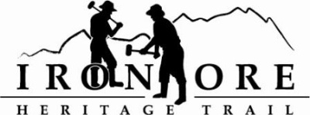
102 W. Washington Suite 232
Marquette, MI 49855
906-235-2923
ironoreheritage@gmail.com

IRON ORE HERITAGE RECREATION AUTHORITY
BOARD MEETING
WEDNESDAY, AUGUST 25, 2021, 4:30 PM
Country Inn/Zoom
AGENDA
- ROLL CALL
- PUBLIC COMMENT (Agenda Items – Limit to three minutes)
- APPROVAL OF CONSENT AGENDA
  - July Minutes
  - July Financials
  - August Bills to be Paid
- APPROVAL OF AGENDA
- OLD BUSINESS
- Michigan Grant Updates
    - Negaunee Township Trailhead
    - Weather Shelters/Fishing Piers/Ribbon Cutting September ?
    - 2021 Trust Fund Purchase of 176 Acres
    - 2021 Trust Fund Negaunee Boardwalk
- 2021 Maintenance List
- Millage Renewal Update
- ORV Parking Lot Options
- Trail Etiquette Signage

- NEW BUSINESS
  - Federal Travel and Tourism Grants American rescue plan grants
  - Cameras on trail
  - Pure Michigan videography
  - Republic Welcoming Center Ribbon Cutting, August 28

- ADMINISTRATOR REPORT
- BOARD COMMENT
- PUBLIC COMMENT
- ADJOURNMENT
NEXT MEETING DATE: September 22, 2021, 4:30 pm, Zoom/Country Inn

