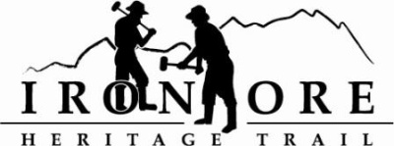
102 W. Washington Suite 232
Marquette, MI 49855
906-235-2923
ironoreheritage@gmail.com

IRON ORE HERITAGE RECREATION AUTHORITY
BOARD MEETING
WEDNESDAY, JULY 28, 2021, 4:30 PM
Country Inn/Zoom
DRAFT AGENDA
- ROLL CALL
- PUBLIC COMMENT (Agenda Items – Limit to three minutes)
- APPROVAL OF CONSENT AGENDA
  - June Minutes
  - June Financials
  - July Bills to be Paid
- APPROVAL OF AGENDA
- OLD BUSINESS
- Michigan Grant Updates
    - Negaunee Township Trailhead
    - Weather Shelters/Fishing Piers
    - 2021 Trust Fund Purchase of 176 Acres
    - 2021 Trust Fund Negaunee Boardwalk
- 2021 Maintenance List
- Millage Renewal Information, Ballot Language and Resolution
- ORV Parking Lot Options

- NEW BUSINESS
  - Trail Rules/Hints Signage
  - Marji Gesick Event Permit
  - Forsyth Request

- ADMINISTRATOR REPORT
- BOARD COMMENT
- PUBLIC COMMENT
- ADJOURNMENT
NEXT MEETING DATE: August 25, 2021, 4:30 pm, Zoom/Country Inn

