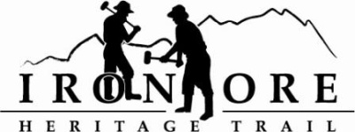
102 W. Washington Suite 232
Marquette, MI 49855
906-235-2923
ironoreheritage@gmail.com

IRON ORE HERITAGE RECREATION AUTHORITY
BOARD MEETING
WEDNESDAY, MARCH 24, 2021, 4:30 PM
Via ZOOM and Country Inn
DRAFT AGENDA
- ROLL CALL
- PUBLIC COMMENT (Agenda Items – Limit to three minutes)
- PUBLIC HEARINGS
  - TRUST FUND ACQUISITION GRANT OF 176 ACRES
  - TRUST FUND DEVELOPMENT GRANT OF NEGAUNEE BOARDWALK
- APPROVAL OF CONSENT AGENDA
  - February Minutes
  - February Financials
  - March Bills to be Paid
- APPROVAL OF AGENDA
- OLD BUSINESS
- Michigan Grant Updates
    - Negaunee Township Trailhead
    - Weather Shelters/Fishing Piers
    - 2021 Trust Fund Purchase of 173 Acres Resolution
    - 2021 Trust Fund Negaunee Boardwalk Resolution
- 2021 Maintenance
  - Republic Township RFQ
- Board Membership Renewals
- Map Meeting Follow up

- NEW BUSINESS
  - Negaunee Jim Thomas Signage Request for $2500
  - Negaunee City Future Projects, ie ORV Campground, Lighting, Trail Connections, Playground, Substation
  - Marquette Lions Park Request
  - Audit Letter Signature
  - City of Ishpeming Request for Campground Board Member

- ADMINISTRATOR REPORT
- BOARD COMMENT.
- PUBLIC COMMENT
- ADJOURNMENT
NEXT MEETING DATE: April 28, 2021, 4:30 pm, Zoom/Country Inn

