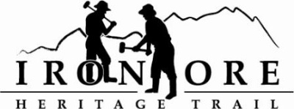
102 W. Washington Suite 232
Marquette, MI 49855
906-235-2923
ironoreheritage@gmail.com

IRON ORE HERITAGE RECREATION AUTHORITY
BOARD MEETING
WEDNESDAY, MAY27 2020, 4:30 PM, COUNTRY INN AND SUITES & ZOOM

DRAFT AGENDA
- ROLL CALL –
- PUBLIC COMMENT (Agenda Items – Limit to three minutes)
- APPROVAL OF CONSENT
  - February Minutes
  - February Financials
  - March, April, May Bills to be Paid
- APPROVAL OF AGENDA
- OLD BUSINESS

- Michigan Grant Updates
    - Negaunee Township Trailhead project
        - Resolution for Trust Fund Grant Application
        - Resolution for Passport Grant Application
    - Ishpeming/Negaunee Lighting Resolution for Trust Fund Grant
    - ORV Grant Request 2021
- 2020 Maintenance List and Updates

- NEW BUSINESS
  - Request for $16K in Lakeshore Erosion Grant Match Money
  - 2020 Amended Budget dated Mary 22, 2020
  - Officer Elections in June
  - Jim Thomas Trailhead Naming
  - 2020 Marquette Marathon Permit

- ADMINISTRATOR REPORT
- BOARD COMMENT.
- PUBLIC COMMENT
- ADJOURNMENT
NEXT MEETING DATE: June 24, 2020, 4:30 pm, Country Inn and Suites

