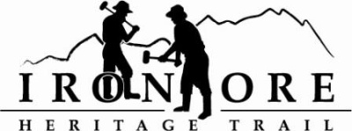
102 W. Washington Suite 232
Marquette, MI 49855
906-235-2923
ironoreheritage@gmail.com

IRON ORE HERITAGE RECREATION AUTHORITY
BOARD MEETING
WEDNESDAY, JANUARY 22, 2020, 4:30 PM, COUNTRY INN AND SUITES

DRAFT AGENDA
- ROLL CALL –
- PUBLIC COMMENT (Agenda Items – Limit to three minutes)
- APPROVAL OF CONSENT
  - December Minutes
  - December Financials
  - January bills to be Paid
- APPROVAL OF AGENDA
- OLD BUSINESS
A. Michigan Grant Updates
    - Trust Fund TF17-0008 Weather Shelters/Fishing Piers
    - Lighting TF19-0026
  - Carp River Kilns Project
  - Lake Superior Erosion Update
  - Ishpeming Ski Club Grooming Update/Trail Work Ishpeming to Negaunee
  - Timber Sale and Harvest Bid/Contract
  - Timber Cutting Behind Negaunee Ice Arena

- NEW BUSINESS
  - 2020 Trail Priorities
    - Marquette Township Paving RFQ specs
    - Finalize Carp River Kiln Project
    - Tilden Township parking specs
  - Michigan DNR Grants Projects 2020
    - Lighting
    - Negaunee Trailhead Development
  - Polar Roll Permit
  - 2020 Board Member Appointments
  - Moose Country Request for Maintenance money for tree clearing
- ADMINISTRATOR REPORT
- BOARD COMMENT
IX. PUBLIC COMMENT
- ADJOURNMENT
NEXT MEETING DATE: February 26, 2020, Country Inn and Suites

