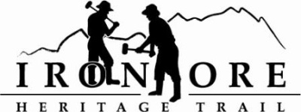
102 W. Washington Suite 232
Marquette, MI 49855
906-235-2923
ironoreheritage@gmail.com
IRON ORE HERITAGE RECREATION AUTHORITY
BOARD MEETING
WEDNESAY, JANUARY 27, 4:30 PM, COUNTRY INN AND SUITES

AGENDA

- ROLL CALL
- PUBLIC COMMENT ( Agenda Items – Limit to three minutes)
- APPROVAL OF CONSENT AGENDA
  - December Board Meeting Minutes
  - December Financials including balance sheet, profit/loss, budget v actual and general ledger
  - January Bills to Be Paid
- APPROVAL OF AGENDA
- OLD BUSINESS
  - Humboldt Washout and RTP and ORV Grant Agreements
  - ORV Ordinance Ishpeming
C. Grant Updates
1. ArtPlace America 2016/MSU Sustainable Built Environment – Cliffs Shaft Area
2. 2015 Recreation Passport Grant Agreement and Resolution
3. 2014 DNR Trust Fund Signage
4. Rails to Trails Doppelt Family Trail Development Fund
D. Millage Renewal Timeline/Resolutions Update/Funding
E. Greenwood Grade Permit
F. New Map

- NEW BUSINESS
  - Future plans if not millage supported
  - Michigan Trails Summit – February 16
- BOARD COMMENT
- PUBLIC COMMENT
- ADJOURNMENT

NEXT MEETING DATE: FEBRUARY 24, 2015, COUNTRY INN AND SUITES

