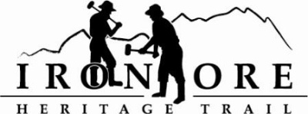
102 W. Washington Suite 232
Marquette, MI 49855
906-235-2923
ironoreheritage@gmail.com
IRON ORE HERITAGE RECREATION AUTHORITY
BOARD MEETING
WEDNESAY, MARCH 23, 4:30 PM, COUNTRY INN AND SUITES
DRAFT AGENDA

- ROLL CALL
- PUBLIC COMMENT ( Agenda Items – Limit to three minutes)

- APPROVAL OF CONSENT AGENDA
  - February Board Meeting Minutes
  - February Financials including balance sheet, profit/loss, budget v actual and general ledger
  - March Bills to Be Paid
- APPROVAL OF AGENDA
- OLD BUSINESS
  - Marquette Township Trailhead Update
  - Humboldt Washout Update
  - ORV Ordinance Ishpeming/ORV 2016 Plans
D. Grant Updates
1. ArtPlace America 2016/MSU Sustainable Built Environment – Cliffs Shaft Area
2. 2015 Recreation Passport Grant Agreement
3. 2014 DNR Trust Fund Signage
E. Millage Renewal/Resolution Update
F. 2016 Map

- NEW BUSINESS
  - Executive Committee Action
  - 2016 Budget Amendment
  - Reappointment of Board Members
  - Officer election candidates
  - Mile marker safety
  - 2016 maintenance/signage schedule
  - City of Marquette Public Art Task Force
- BOARD COMMENT
- PUBLIC COMMENT
- ADJOURNMENT

NEXT MEETING DATE: APRIL 27, 2015, COUNTRY INN AND SUITES

