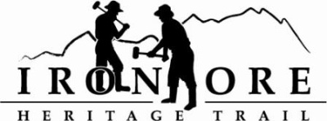
337 W. Washington Street
Marquette, MI 49855
906-235-2923 fax 906-228-3642
ironoreheritage@gmail.com
IRON ORE HERITAGE RECREATION AUTHORITY
WEDNESDAY, JULY 23, 2014, 4:30 PM
COUNTRY INN AND SUITES
DRAFT AGENDA

- ROLL CALL
- PUBLIC COMMENT ( Agenda Items – Limit to three minutes)
- CONSENT AGENDA
  - Approval of Board Meeting Minutes of June 25 2014
  - June Financials and July Bills to be Paid

- APPROVAL OF AGENDA

- OLD BUSINESS
  - Phase IV – Tilden/Republic
  - ATV Trail Plans
  - Adopt a Mile Policy
  - Maintenance and Installations
a. Vandenboom/492/Northwoods Road
b. Chocolay Bridges
c. Trail Maintenance
d. Kiosk and panel installations
e. Directional signage installations

- NEW BUSINESS
A. Change of August meeting date
C. Non-motorized trail workshop agenda
D. Audit 2011, 2012, 2013
E. September tour with Travel Writer
E. October pre-MML Conference workshop
F. Michigan Council for Arts and Cultural Affairs Grant
G. Event Permits
- ADMINISTRATOR REPORT
- BOARD COMMENT
- PUBLIC COMMENT
- ADJOURNMENT

NEXT MEETING DATE: TBD, COUNTRY INN AND SUITES

