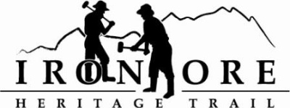
337 W. Washington Street
Marquette, MI 49855
906-235-2923 fax 906-228-3642
ironoreheritage@gmail.com

IRON ORE HERITAGE RECREATION AUTHORITY
JUNE 26, 2013 4:30 PM
COUNTRY INN AND SUITES

AGENDA

- WELCOME / ROLL CALL
- PUBLIC COMMENT ( Agenda Items – Limit to three minutes)
- CONSENT AGENDA
  - Approval of Board Meeting Minutes of May 22
  - Financials: May Balance Sheet, Profit/Loss, Actual vs. Budget, Check Detail, Deposit Detail, June Bills to be Paid

- APPROVAL OF AGENDA
- OLD BUSINESS
  - Director’s Orders Update Eagle Mills Grade and Greenwood Grade
    - Resolution
  - Negaunee to Marquette Construction Updates
    - Engineer Change Order Request
  - Map Update
  - Trust Fund 12-049 Agreement
    - Scope Change
    - Resolution

- NEW BUSINESS
  - Trail Opening Ribbon Cutting/Party – Tentative August 13
  - Grant Work Session
- REPORTS (Meetings/Seminars attended)/CORRESPONDENCE
A. Lake Bancroft Request
- BOARD COMMENT
- PUBLIC COMMENT
- ADJOURNMENT

NEXT MEETING DATE: WEDNESDAY, JULY 31, 4:30 PM, COUNTRY INN AND SUITES

