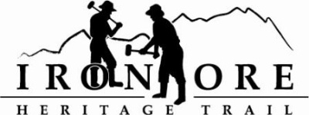
337 W. Washington Street
Marquette, MI 49855
906-235-2923 fax 906-228-3642
ironoreheritage@gmail.com

IRON ORE HERITAGE RECREATION AUTHORITY
MARCH 27, 2013 4:30 PM
COUNTRY INN AND SUITES
AGENDA

- WELCOME / ROLL CALL
- PUBLIC COMMENT ( Agenda Items – Limit to three minutes)
- CONSENT AGENDA
  - Approval of Board Meeting Minutes: February 27
  - Approval of Executive Committee Meeting Minutes March 13
  - Financials February Balance Sheet, Profit/Loss, Actual vs. Budget, Check Detail, Deposit Detail,

- APPROVAL OF CONSENT AGENDA
- APPROVAL OF AGENDA
- OLD BUSINESS
  - Resolution – Amendment to DNR Trust Fund – Negaunee to Marquette
  - Ely Township Millage Request
  - Tilden Township Trail Engineering Work
  - ATV Updates
    - Ishpeming Route
  - Land Management
  - Trail Map

- NEW BUSINESS
  - Bid Policy
  - Executive Committee
  - Fundraising/Donations
  - March Bills to be Paid

- REPORTS (Meetings/Seminars attended)/CORRESPONDENCE
- BOARD COMMENT
- PUBLIC COMMENT
- ADJOURNMENT

NEXT MEETING DATE: WEDNESDAY, APRIL 24, 4:30 PM, COUNTRY INN AND SUITES

