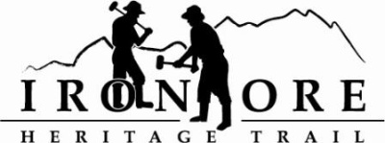
102 W. Washington Suite 232
Marquette, MI 49855
906-235-2923
ironoreheritage@gmail.com

IRON ORE HERITAGE RECREATION AUTHORITY
BOARD MEETING MINUTES
WEDNESDAY, OCTOBER 24, 2018, 4:30 PM
COUNTRY INN AND SUITES
DRAFT AGENDA

- ROLL CALL
- PUBLIC COMMENT ( Agenda Items – Limit to three minutes)
- APPROVAL OF CONSENT AGENDA -
  - September Meeting Minutes
  - September Financials
  - October Bills to be Paid
- APPROVAL OF AGENDA
- OLD BUSINESS
A. Michigan Grant Updates
    - Trust Fund TF17-0008 Weather Shelters/Fishing Piers
    - Lighting TF18-0072
    - 492/35 Trailhead Purchase & Upgrades TF18-0032
  - Carp River Kilns Project
    - MCACA Grant
    - Shiras Check Presentation
    - Tree removal and fill bid
  - Pure Michigan Trail Resolution
  - ORV updates
  - Maintenance Items List
V. NEW BUSINESS
- 2018 Budget Amendment October 2018
- 2019 Draft Budget
- Purchasing Policy Review
- Book of interpretive signs
- ADMINISTRATOR REPORT
- BOARD COMMENT
IX. PUBLIC COMMENT
X. ADJOURNMENT
NEXT MEETING DATE: Wednesday, November 28, 4:30 pm, Country Inn and Suites

