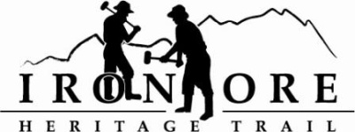
102 W. Washington Suite 232
Marquette, MI 49855
906-235-2923
ironoreheritage@gmail.com

IRON ORE HERITAGE RECREATION AUTHORITY
BOARD MEETING MINUTES
WEDNESDAY, SEPTEMBER 26, 2018, 4:30 PM
COUNTRY INN AND SUITES
DRAFT AGENDA

- ROLL CALL
- PUBLIC COMMENT ( Agenda Items – Limit to three minutes)
- APPROVAL OF CONSENT AGENDA -
  - August Meeting Minutes
  - August Financials
  - September Bills to be Paid
- APPROVAL OF AGENDA
- OLD BUSINESS
A. Michigan Grant Updates
    - Trust Fund TF17-0008 Weather Shelters/Fishing Piers
    - Lighting TF18-0072
    - 492/35 Trailhead Purchase & Upgrades TF18-0032
  - Carp River Kilns Project
    - MCACA Grant Signature
    - Timeline of projects
C. ORV updates
D. Maintenance Items List
V. NEW BUSINESS
- Photo contract J. Birdie
- Mile Markers
- Pure Michigan Trail Designation Process
- TART Trail Visit
- ADMINISTRATOR REPORT
- BOARD COMMENT
IX. PUBLIC COMMENT
X. ADJOURNMENT
NEXT MEETING DATE: October 24, 2018, 4:30 pm, Country Inn and Suites

