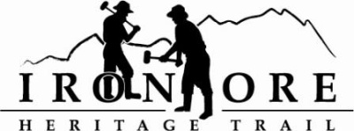
102 W. Washington Suite 232
Marquette, MI 49855
906-235-2923
ironoreheritage@gmail.com

IRON ORE HERITAGE RECREATION AUTHORITY
BOARD MEETING MINUTES
WEDNESDAY, AUGUST 22, 2018, 4:30 PM
COUNTRY INN AND SUITES
DRAFT AGENDA

- ROLL CALL
- PUBLIC COMMENT ( Agenda Items – Limit to three minutes)
- APPROVAL OF CONSENT AGENDA -
  - July Meeting Minutes
  - July Financials -
  - August Bills to be Paid
- APPROVAL OF AGENDA
- OLD BUSINESS
A. Michigan Grant Updates
    - Trust Fund TF-0157 Weather Shelters
    - Lighting
    - 492/35 Trailhead Purchase & Upgrades
B. Carp River Kilns Grants
C. ORV updates
D. Maintenance Items List
V. NEW BUSINESS
- Photo contract
- Mile Markers

VII ADMINISTRATOR REPORT
- BOARD COMMENT
- PUBLIC COMMENT
- ADJOURNMENT
NEXT MEETING DATE: September 26, 2018, 4:30 pm, Country Inn and Suites

