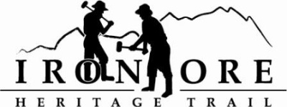
102 W. Washington Suite 232
Marquette, MI 49855
906-235-2923
ironoreheritage@gmail.com

IRON ORE HERITAGE RECREATION AUTHORITY
BOARD MEETING MINUTES
WEDNESDAY, JUNE 27, 2018, 4:30 PM
COUNTRY INN AND SUITES
DRAFT AGENDA

- ROLL CALL
- PUBLIC COMMENT ( Agenda Items – Limit to three minutes)
- APPROVAL OF CONSENT AGENDA -
  - May Meeting Minutes
  - May Financials -
  - June Bills to be Paid
- APPROVAL OF AGENDA
- OLD BUSINESS
A. Michigan Grant Updates
  - Recreation Passport Trailhead Amenities
  - Trust Fund TF-0157 Weather Shelters Resolution to Accept Project Agreement
  - Regional Prosperity 2017
- Projects
1. Lighting
2. Carp River Kilns Memorandum of Understanding
3. Father Marquette artwork and Invite

C. ORV updates
1. ORV grant work
3. DEQ Permit for Negaunee wetlands reroute and cost
4. Chocolay Planning Committee meeting

V. NEW BUSINESS
  - Maintenance Items
    - BIDS – 492/35 west to asphalt before r/r crossing
    - Other items on list
    - Bidding Projects – Ishpeming/Negaunee asphalt bumps (270 feet)
  - Future projects and cash flow
  - National Recreation Trail Designation

VII ADMINISTRATOR REPORT
- BOARD COMMENT
- PUBLIC COMMENT
- ADJOURNMENT
NEXT MEETING DATE: July 25, 2018, 4:30 pm, Country Inn and Suites

