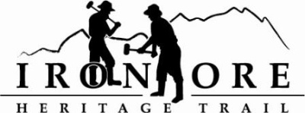
102 W. Washington Suite 232
Marquette, MI 49855
906-235-2923
ironoreheritage@gmail.com

IRON ORE HERITAGE RECREATION AUTHORITY
BOARD MEETING MINUTES
TUESDAY, MAY 22, 2018, 4:30 PM
COUNTRY INN AND SUITES
DRAFT AGENDA

- ROLL CALL
- PUBLIC COMMENT ( Agenda Items – Limit to three minutes)
- APPROVAL OF CONSENT AGENDA -
  - March Meeting Minutes
  - March Financials -
  - April Bills to be Paid
- APPROVAL OF AGENDA
- OLD BUSINESS
A. Michigan Grant Updates
  - Recreation Passport Trailhead Amenities Bid Options
  - Trust Fund TF-0157 Weather Shelters
  - Regional Prosperity 2017
- Projects
1. Lighting
2. Carp River Kilns – Marquette License to Use Agreement
a. Marquette License to Use Agreement
b. Michigan Council for Arts & Cultural Affairs Approval
3. ORV updates
3. Father Marquette art entrance updates/drawings

V. NEW BUSINESS
  - 2018 Budget Amendment
  - Maintenance Items
  - NCLL trail walk May 30
  - Trail Counters

VII ADMINISTRATOR REPORT
- BOARD COMMENT
- PUBLIC COMMENT
- ADJOURNMENT
NEXT MEETING DATE: June 27, 2018, 4:30 pm, Country Inn and Suites

