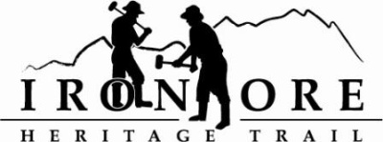
102 W. Washington Suite 232
Marquette, MI 49855
906-235-2923
ironoreheritage@gmail.com

IRON ORE HERITAGE RECREATION AUTHORITY
BOARD MEETING
WEDNESDAY, MARCH 28, 2018, 4:30 PM
COUNTRY INN AND SUITES
AGENDA

- ROLL CALL
- PUBLIC HEARING – Michigan Natural Resources Trust Fund Grant Application
  - Acquisition Grant, Purchase of property for Negaunee Township Trail Head
  - Development Grant, Lighting of Trail between Ishpeming and Negaunee

- PUBLIC COMMENT ( Agenda Items – Limit to three minutes)
- APPROVAL OF CONSENT AGENDA
  - February Meeting Minutes
  - February Financials
  - March Bills to be Paid
- APPROVAL OF AGENDA
- OLD BUSINESS
A. Grant Updates
  - Recreation Passport Trailhead Amenities Bid Options
  - Trust Fund TF-0157 Weather Shelters
  - Regional Prosperity 2017
B. Michigan Natural Resource Trust Fund Application
1. Acquisition Resolution
2. Development Resolution
C. Grants
1. Lighting
2. Carp River Kilns

V. NEW BUSINESS
  - Executive Board Slate of Candidates
  - 2018 Trail Work
  - Events

VII ADMINISTRATOR REPORT
- BOARD COMMENT
- PUBLIC COMMENT
- ADJOURNMENT
NEXT MEETING DATE: April 26, 2018, Country Inn and Suites, Board Appreciation Get Together Afterward at Buffalo Wild Wings

