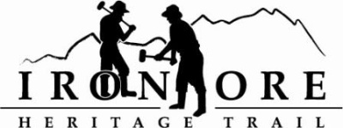
102 W. Washington Suite 232
Marquette, MI 49855
906-235-2923
ironoreheritage@gmail.com

IRON ORE HERITAGE RECREATION AUTHORITY
BOARD MEETING
WEDNESDAY, FEBRUARY 28, 2018, 4:30 PM
COUNTRY INN AND SUITES
AGENDA

- ROLL CALL

- PUBLIC COMMENT ( Agenda Items – Limit to three minutes)
- APPROVAL OF CONSENT AGENDA
  - January Meeting Minutes
  - January Financials
  - February Bills to be Paid
- APPROVAL OF AGENDA
- OLD BUSINESS
A. Grant Updates
  - Recreation Passport Trailhead Amenities Bid Options
  - Trust Fund TF-0157 Weather Shelters
  - Regional Prosperity 2017
B. Reappointments to Board

VI. NEW BUSINESS
  - 2018-19 Projects Proposed
    - Acquisition of 3 acres Negaunee Township for Trailhead
        - 2018 DNR Trust Fund Acquisition
    - Lighting between Ishpeming and Negaunee
        - 2018 Recreation Passport Grant
b. 2018 Spring Western Marquette County Health Foundation
c. 2018 UPPCO Grants
3. Carp River Kiln Restoration
a. March 2018 Shiras Institute
b. MCACA June 2018
c. Kaufman Foundation
  - Michigan Trails Conference Report
  - ORV Grant 2018-19
  - Ishpeming Request for Resolution on Five Year Recreation Plan
VII ADMINISTRATOR REPORT
- BOARD COMMENT
- PUBLIC COMMENT
- ADJOURNMENT.
NEXT MEETING DATE: March 28, 2018, Country Inn and Suites

