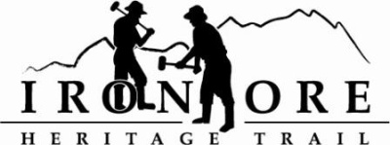
102 W. Washington Suite 232
Marquette, MI 49855
906-235-2923
ironoreheritage@gmail.com

IRON ORE HERITAGE RECREATION AUTHORITY
BOARD MEETING
WEDNESDAY, DECEMBER 20, 2017, 4:30 PM
COUNTRY INN AND SUITES
DRAFT AGENDA

- ROLL CALL
- PUBLIC COMMENT ( Agenda Items – Limit to three minutes)
- APPROVAL OF CONSENT AGENDA
  - November Meeting Minutes
  - November Financials
  - December Bills to be Paid
- APPROVAL OF AGENDA
- OLD BUSINESS
A. Grant Updates
  - Recreation Passport Trailhead Amenities Bid Options
  - Trust Fund TF-0157 Weather Shelters
  - Regional Prosperity 2017
C. Five Year Recreation Plan
E. Shared Use Trail in East Negaunee/Wetlands Area Updates

VI. NEW BUSINESS
  - Event Permits
  - Audit Quote
  - E-Bike Legislation
  - 2018 Meeting Schedule
  - Chocolay Township
  - Municipal Report 2018

VII ADMINISTRATOR REPORT
- BOARD COMMENT
- PUBLIC COMMENT
- ADJOURNMENT
NEXT MEETING DATE: Proposed: January 24, 2018, Country Inn and Suites

