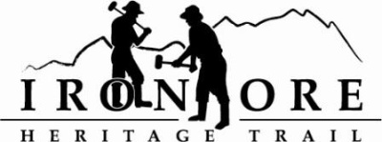
102 W. Washington Suite 232
Marquette, MI 49855
906-235-2923
ironoreheritage@gmail.com
IRON ORE HERITAGE RECREATION AUTHORITY
BOARD MEETING
WEDNESDAY, JUNE 28, 2017, 4:30 PM
ASPEN RIDGE SCHOOL
DRAFT AGENDA

- ROLL CALL
- PUBLIC COMMENT ( Agenda Items – Limit to three minutes)
- APPROVAL OF CONSENT AGENDA -
A. MAY Board Meeting Minutes
B. May Financials including balance sheet, profit/loss, budget v actual and general ledger
C. June Bills to be Paid
- APPROVAL OF AGENDA
- OLD BUSINESS
A. Grant Updates
  - Recreation Passport Trailhead Amenities
  - Trust Fund TF-0157 Weather Shelters
  - Regional Prosperity 2017
B. Trail Signage/Road Crossing
C. ORV Updates
D.. Trail Maintenance
1. Pavement Markings
2. Trimming/ Grass Cutting
VI. NEW BUSINESS
A. 2017 Budget Amendment
B. Bell Auxiliary Donation
C. Trail Amenities
1. Benches
2. Trail Counters

VII ADMINISTRATOR REPORT
- BOARD COMMENT
- PUBLIC COMMENT
- ADJOURNMENT
NEXT MEETING DATE:/ANNUAL MEETING: July 25, 4:30 pm, Country Inn and Suites

